


ADVANCED SPREADSHEET APPLICATIONS
(235)

STATE – 2020

Production:

Printout 1 (105 points)

Printout 2 (185 points)

Printout 3 (110 points)

TOTAL POINTS (400 points)

Judge/Graders: Please double check and verify all scores and answer keys!

Property of Business Professionals of America.
May be reproduced only for use in the Business Professionals of America
Workplace Skills Assessment Program competition.

General Instructions
Key your contestant number and printout number in the right section of a footer on each printout on a separate line in the footer. Your name or initials should not appear on any work you submit.

- Center the following information in a header on each printout: File name and the sheet name. Each item should appear on a separate line in the header.
- If you finish before the end of the testing time, notify the proctor. Time may be a factor in determining the winner in the event of a tie.

- When turning in your contest, arrange all jobs in the correct printout order (included in instructions).

- Write your contestant number in the provided spaces on the test cover page.

Formatting on Printout 1 (all or nothing for points) | Points | Total Points
Contestant Number and Printout # in right section of footer | 5
Sheet Name (PayReport) in center of header | 5
Insert 3 new rows at the top of the spreadsheet. | 5
- Type the following information  - A1: Equipment Summary  - A2: Number of items checked out | 10
Format the cell A1 Center and merge, heading 1 | 5
Format the cell A2 Center and merge, heading 2 | 5
Left align all Equipment ID numbers | 5
Name Worksheet 1 – Summary Data | 5
Name Worksheet 2 –Equipment Data | 5
Insert the text file in cell A13 of the second worksheet. | 5
Define Worksheet 2 data A2:D12 to a table named DataTable. | 5
Print Equipment Data worksheet in portrait orientation. Make sure that no data is truncated. This is Printout 1. | 5
Typos (0 errors 40 points, 1 error 30 points, 2 errors 20 points, 3 errors 10 points, 4 or more 0 points) | 40
Total Printout 1 | 105

Formulas on Printout 2 | Points | Total Points
Contestant Number and Printout # in right section of footer | 5
VLOOKUP function in B5 – must contain DataTable in formula. Fill function down. | 20
VLOOKUP function in C5 – must contain DataTable in formula. Fill function down. | 20
VLOOKUP function in D5 – must contain DataTable in formula. Fill function down. | 20
Use the IF LEN function along with the VLOOKUP function in cell E5 – must contain DataTable in formula. Fill function down. | 30
VLOOKUP function in F5 – must contain DataTable in formula. Fill function down. | 20
Insert a function in cell E16 that counts the number of laptops that have not been turned in. | 10
Format cell E16 to number with 0 decimals | 5
A4:E14 converted to a Table and include a Header Row, Last Column, and Banded Row | 20
Apply conditional formatting to E4:E14 creating a new rule:  - Format only cells that contain  - Blanks  - Format pattern color to red with horizontal stripes | 15
Set print area of A1:F16 | 5
Printed in landscape orientation, centered horizontally and vertically, fit to one page with not truncated data (all or nothing points) | 15
Total Printout 2 | 185

Pivot Table and Chart (all or nothing for points) | Points | Total Points
Inserted Contestant Number and Printout # in right section of footer | 5
Create a pivot table and chart from the data on the Equipment Data worksheet that will display on a new sheet named Pivotable chart. The Table should display:  - Values: Equipment detail  - Axis: Type | 20
The chart should be formatted as:  - Fit the chart in the range A10:H28  - Apply Chart Style 10  - Chart title “Equipment Type Totals” above chart  - Remove legend  - Select Chart layout 10  - Name Pivotablechart | 30
Printed in landscape orientation, centered vertically and horizontally, fit to one page with not truncated data (all or nothing points) | 15
Typos (0 errors 40 points, 1 error 30 points, 2 errors 20 points, 3 errors 10 points, 4 or more 0 points) | 40
Total Printout 3 | 110
Total Points | 400

JOB 1
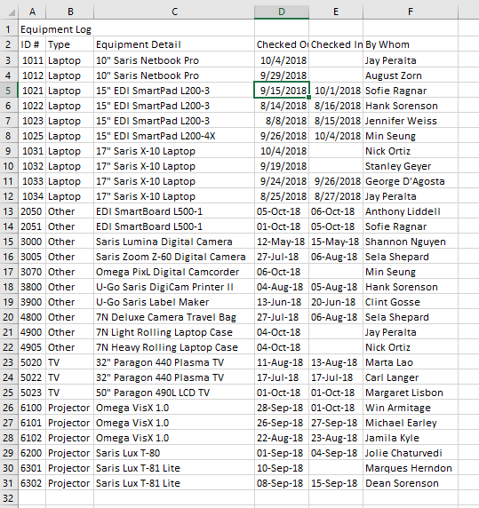

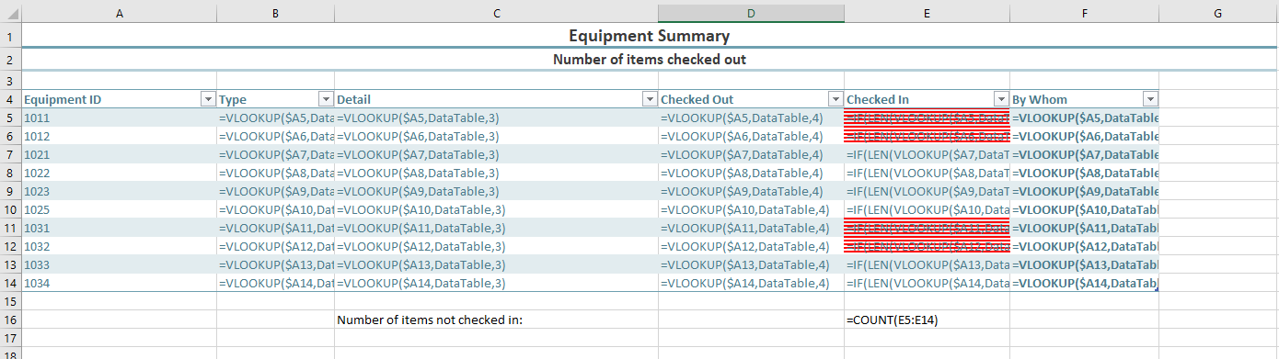 JOB 2

JOB 3

